Query the Table (Screenshots)

Shows all things in the table.

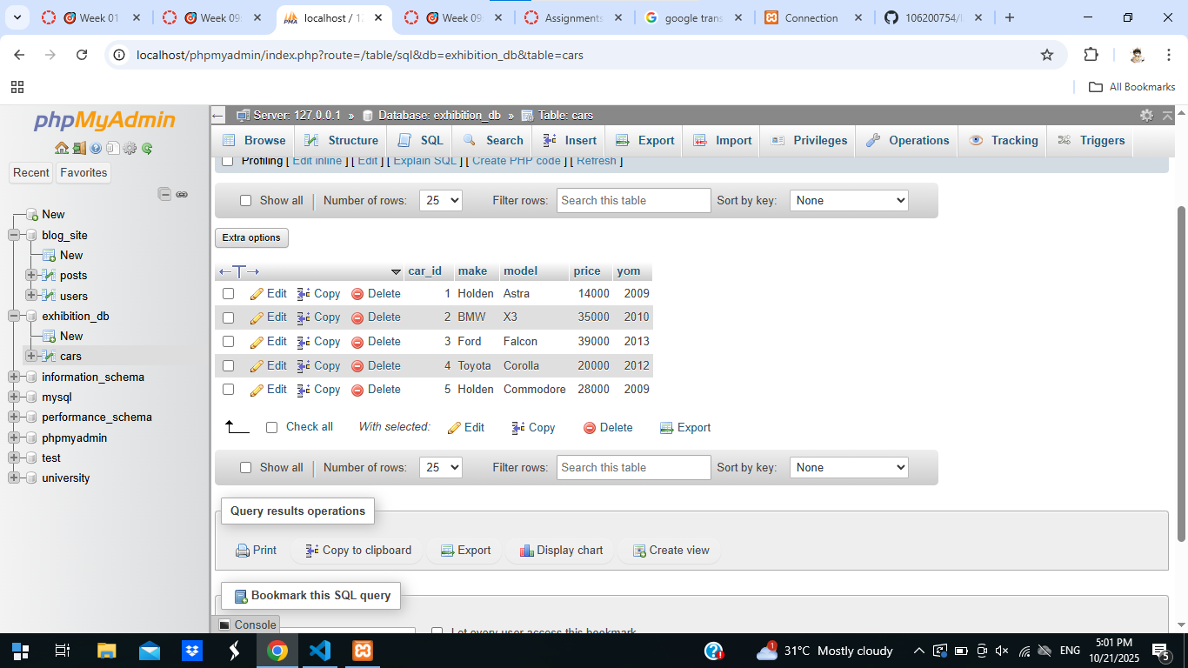

Shows make, mode and price column; sort in order in the make column.

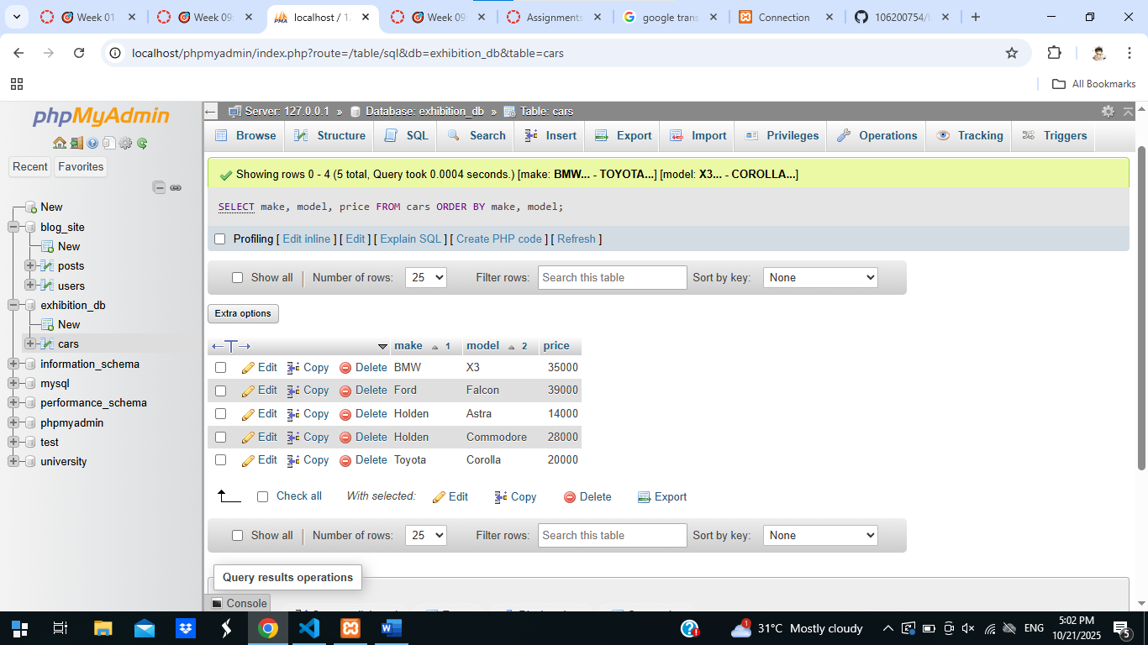

Shows make and model column where the price is equal or greater than 20000.

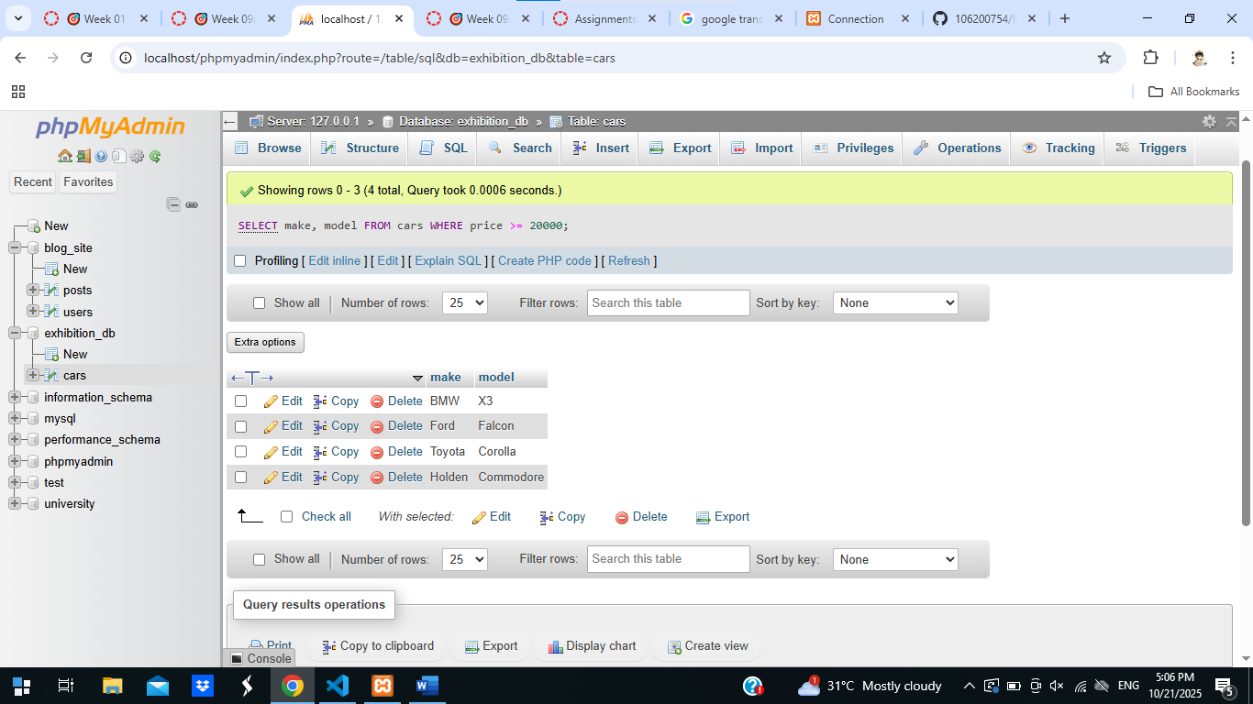

Shows make and price column with the average of price and group the same value together in make column.

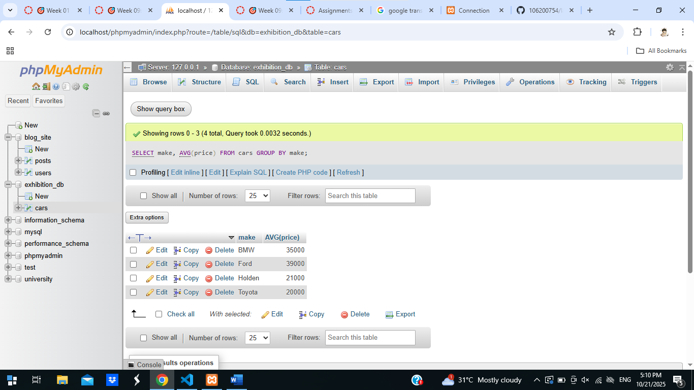

Shows make and model column where the price is under 15000 and greater than 10000.

